Lab 29 - Layer 2 CDP Attack

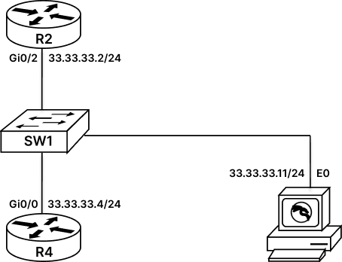

Configure Layer 2 CDP Attack
CDP is Cisco Discovery Protocol, which is used by Cisco devices to discover directly connect neighbors. By default, CDP protocol is enabled on Cisco Switches, which helps Cisco Switches to discover directly connected devices and populate this information in its CDP Table.
However, attacker can leverage this default feature of Switches and perform CDP attack on switches. To do this attacker can use Kali Machine and inbuilt Layer 2 attack tool that is “Yersinia”.
Yersinia is a framework that is used in Kali Machine to perform Layer 2 attack. In this LAB, we will be using this tool to perform CDP attack on our switch and flood the CDP table with fictious CDP entries thus exhausting the resources of the switch.
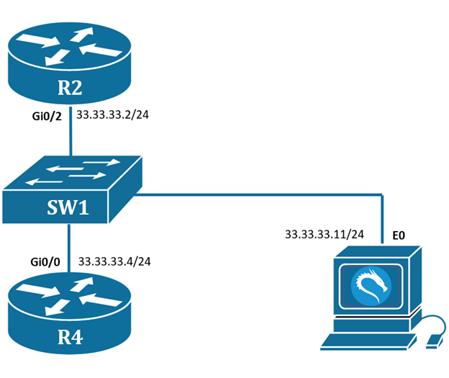
Task 1: Verify the CDP table on Cisco Switch
Step 1: To start with this lab, we will first give the IP address to our routers as the interface of router is by default shut. Then we will verify the CDP table of the switch. This will give us the information of directly connected cisco devices.
R2#conf t
R2(config)#int gi0/2
R2(config-if)#ip add 33.33.33.2 255.255.255.0
R2(config-if)#no shutdown
R2(config-if)#exit
----------------------------------------------------
R4#conf t
R4(config)#int gi0/0
R4(config-if)#ip add 33.33.33.4 255.255.255.0
R4(config-if)#no shutdown
R4(config-if)#exit
Step 2: Verify the CDP table of Switch
SW1#sh cdp neighbors
Capability Codes: R - Router, T - Trans Bridge, B - Source Route Bridge
S - Switch, H - Host, I - IGMP, r - Repeater, P - Phone,
D - Remote, C - CVTA, M - Two-port Mac Relay

Device ID Local Intrfce Holdtme Capability Platform Port ID
R2 Gig 0/2 160 R B Gig 0/2
R4 Gig 0/3 179 R B Gig 0/0

Total cdp entries displayed : 2
SW1#
Now as we can see, the cdp table shows that cisco switch has discovered R2 and R4 router, where R2 is connected via local interface of Gi0/2 of switch to the remote Port ID of Gi0/2 of R2 router and R4 is connected via local interface of Gi0/3 of switch to the remote Port ID of Gi0/0 of R4 router.
By default, CDP sends Hello Packets every 60 Seconds to its neighbor and if it fails to receive approximately 3 Hello Packets(180 Seconds) from its neighbor, then it considers that the neighbor is dead and then remove its entry from its CDP table.
Task 2: L2 CDP Flooding using Kali Linux
Step 1: We will take access of kali machine
username : root
password : rst@12345
From kali machine open terminal and type ‘yersinia -G’.
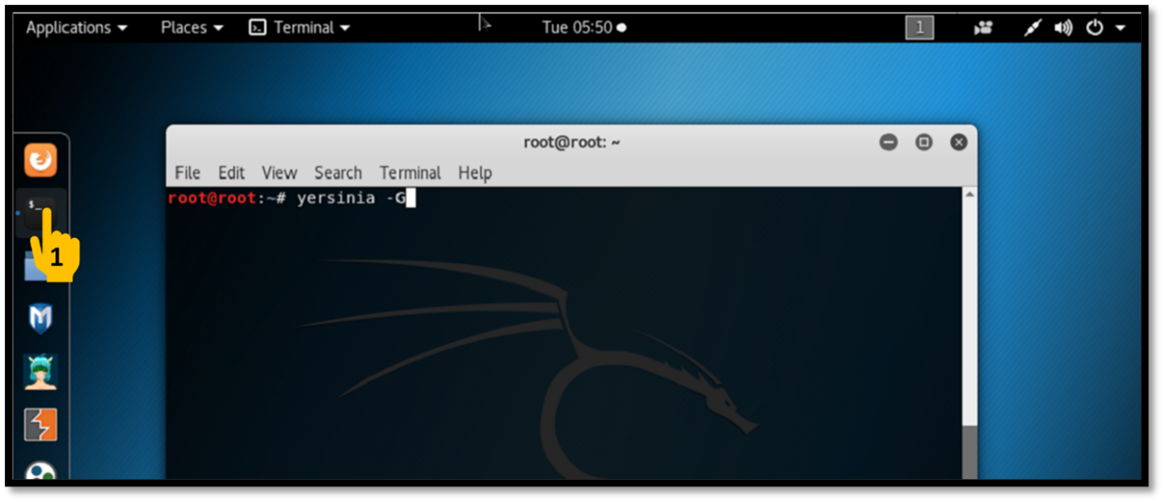
Step 2: After opening up yersinia we would get a notification stating its an Alpha Version, this can be ignored. After this prompt, we can see that within some seconds Kali has also discovered the CDP packets from Switch. If we Click on the Device name, we can see more information of the device sending this CDP packet.
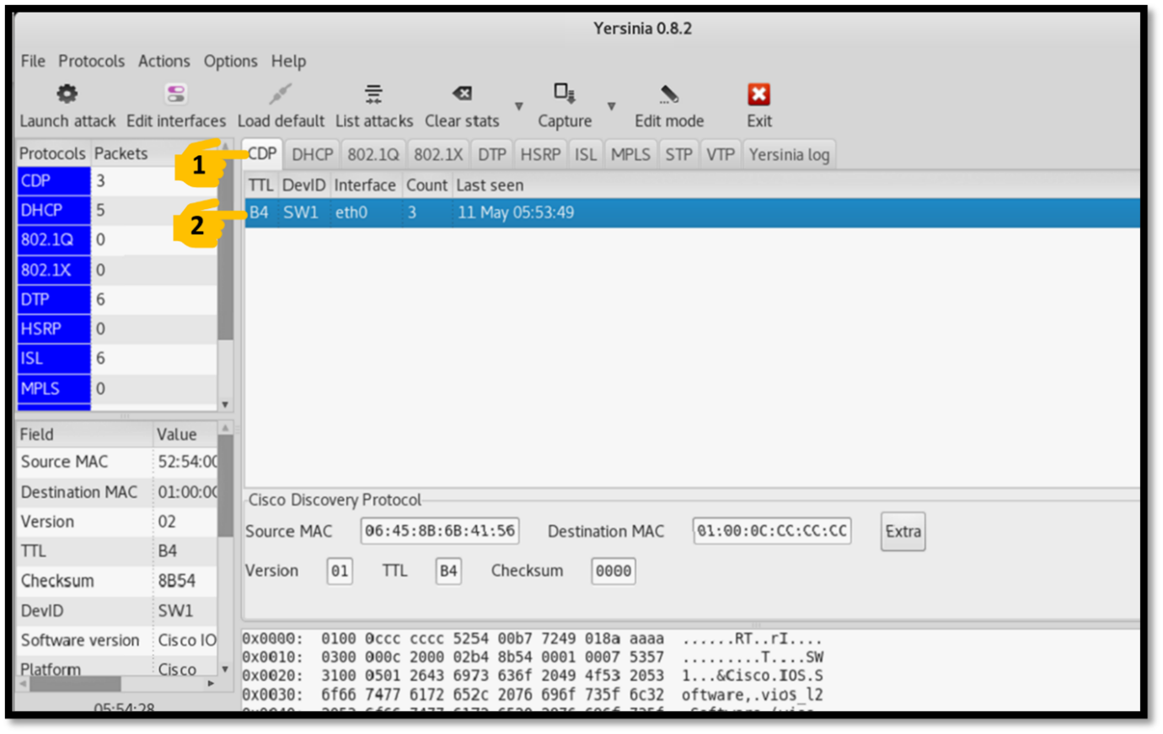
Step 3: Now we will flood the CDP table of Switch using this tool, Go to CDP > SW1 > Launch Attack > CDP > flooding CDP table >
NOTE!!! After clicking OK, make sure to click on EXIT.
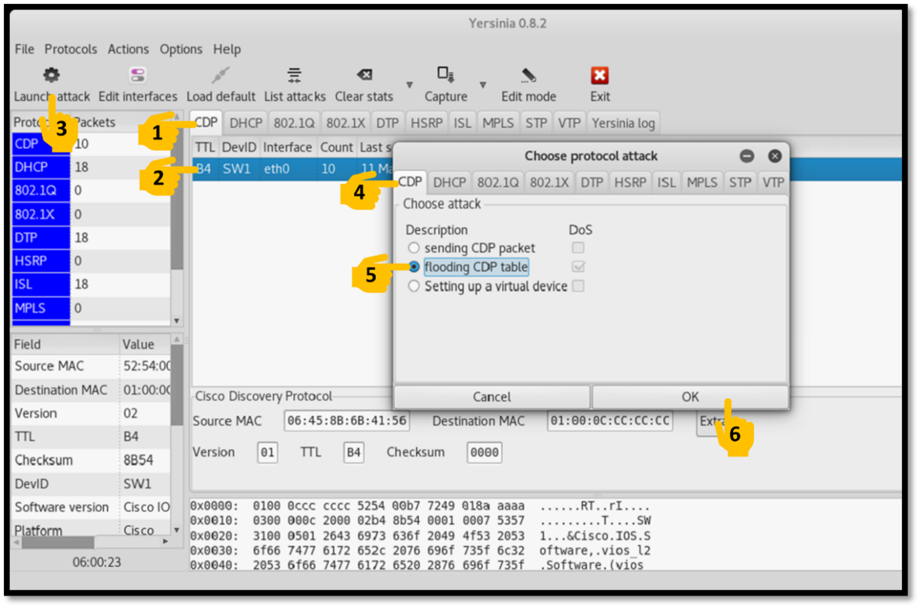
Step 4: Now after Exiting from yersinia, now go to Switch and verify the CDP table. It must be flooded with fictitious CDP entries.
SW1#sh cdp neighbors
-----------------------------Output Trimmed---------------------------------
D SW1#sh cdp neighbors
Capability Codes: R - Router, T - Trans Bridge, B - Source Route Bridge
S - Switch, H - Host, I - IGMP, r - Repeater, P - Phone,
D - Remote, C - CVTA, M - Two-port Mac Relay

Device ID Local Intrfce Holdtme Capability Platform Port ID
0NNNNNN Gig 0/1 250 R H I yersinia Eth 0
00000NN Gig 0/1 251 R H I yersinia Eth 0
WW00000 Gig 0/1 245 R T B r yersinia Eth 0
VVVV000 Gig 0/1 244 R T B r yersinia Eth 0
--More-
Task 3: Mitigate CDP Flood Attack
Step 1: To mitigate this kind of attack we should simply disable CDP from the idle interface of switch.
SW1#conf t
SW1(config)#int gi0/1
SW1(config-if)#no cdp enable
SW1#clear cdp table
Step 2: Go to Kali Linux, Open “Terminal” and type “yersinia -G”.
Now even after waiting we will not be able to see CDP messages on yersinia.
